MATHS ASSIGNMENT

Abhilash ravichandran

2023-04-11

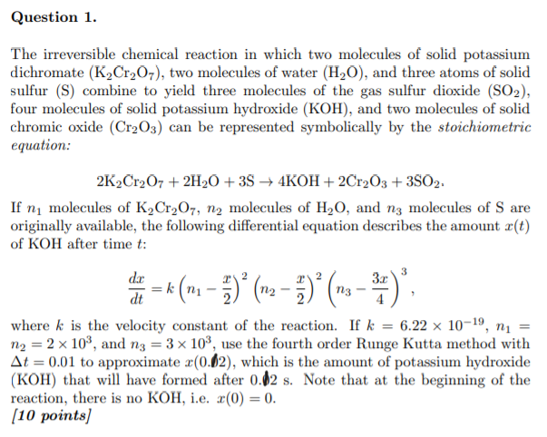## Answer :

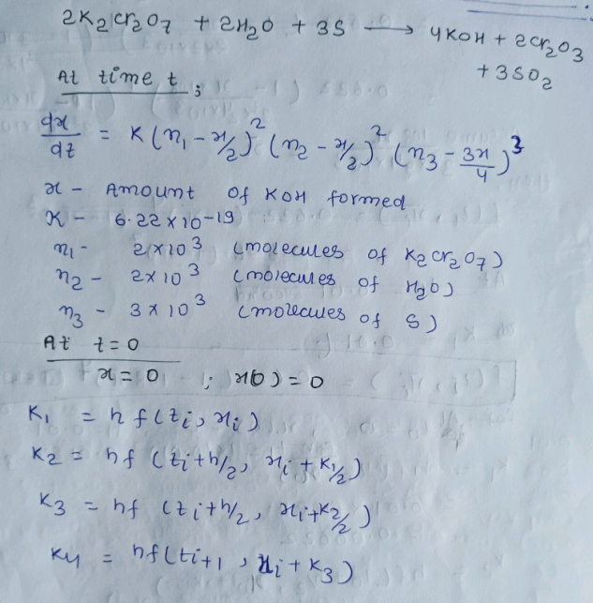

DIFFERENTIAL EQUATION

*#x(t)=6.22*10^-19*(2*10^3-x/2)^2*(2*10^3-x/2)^2*(3*10^3-3x/4)^3*  
*#ASSUMING X/432*1000=x*  
*#x(t)=0.622*((1-(108*x))^4)*((1-(108*x))^3*

## CODE FOR SOLVING RUNGE KUTTA 4TH ORDER MTD

fx=**function**(x=0,h=0.01){  
 n=20 *#Number of iterations*  
 **for** (i **in** seq(1,n,1)){ *#for loop*   
 message("for t= ",h*i)  
 k1=h*(0.622*((1-(108*x))^4)*((1-(108*x))^3)) *#k1=hf(ti,xi)*  
 a=(k1)  
 message("k1 is: ",a)  
 u=x+(a)/2  
 k2=h*(0.622*((1-(108*u))^4)*((1-(108*u))^3)) *#k2=hf(ti+h/2,xi+k1/2)*  
 b=(k2)  
 message("k2 is: ",b)  
 u=x+(b)/2  
 k3=h*(0.622*((1-(108*u))^4)*((1-(108*u))^3)) *#k3=hf(ti+h/2,xi+k2/2)*  
 c=(k3)  
 message("k3 is: ",c)  
 u=x+(c)  
 k4=h*(0.622*((1-(108*u))^4)*((1-(108*u))^3)) *#k4=hf(ti+1,x+k3)*  
 d=(k4)  
 message("k4 is: ",d)  
 t=(a+2*b+2*c+d) *#y(i+1)=yi+1/6(k1+2k2+2k3+k4)*  
 y=x+(1/6)*t  
 q=print(y)  
 ***##***  
 x=q  
 }  
 return(q)  
   
   
}  
print(fx())

_____________________________________________________________________________

#output::

## for t= 0.01

## k1 is: 0.00622

## k2 is: 0.000354418431549009

## k3 is: 0.00543305257041571

## k4 is: 1.27978100298382e-05

## [1] 0.002967957

## for t= 0.02

## k1 is: 0.000415853829960973

## k2 is: 0.00032867687414326

## k3 is: 0.000345520695822096

## k4 is: 0.000280039639251511

## [1] 0.003308671

## for t= 0.03

## k1 is: 0.000281627963080798

## k2 is: 0.0002381613469517

## k3 is: 0.00024446820114602

## k4 is: 0.000209963011616511

## [1] 0.00355148

## for t= 0.04

## k1 is: 0.000210390918611421

## k2 is: 0.000184703590306619

## k3 is: 0.000187688023580711

## k4 is: 0.000166487105088597

## [1] 0.003738423

## for t= 0.05

## k1 is: 0.00016664434474835

## k2 is: 0.000149816372066146

## k3 is: 0.000151446701396092

## k4 is: 0.000137161082973052

## [1] 0.003889479

## for t= 0.06

## k1 is: 0.000137231093457452

## k2 is: 0.000125416887348601

## k3 is: 0.000126398430385059

## k4 is: 0.000116154843700299

## [1] 0.004015648

## for t= 0.07

## k1 is: 0.000116190359311241

## k2 is: 0.00010747329910596

## k3 is: 0.000108107230028045

## k4 is: 0.000100424159074823

## [1] 0.004123611

## for t= 0.08

## k1 is: 0.000100443958838926

## k2 is: 9.37666642539923e-05

## k3 is: 9.41984269344273e-05

## k4 is: 8.82358505602226e-05

## [1] 0.004217712

## for t= 0.09

## k1 is: 8.82477059503624e-05

## k2 is: 8.29811694277446e-05

## k3 is: 8.32877277796049e-05

## k4 is: 7.85346498399315e-05

## [1] 0.004300932

## for t= 0.1

## k1 is: 7.85421566285735e-05

## k2 is: 7.42897652524232e-05

## k3 is: 7.45148321862827e-05

## k4 is: 7.06430327045533e-05

## [1] 0.004375398

## for t= 0.11

## k1 is: 7.06480045331198e-05

## k2 is: 6.71478070219839e-05

## k3 is: 6.731765172291e-05

## k4 is: 6.41069551349594e-05

## [1] 0.004442679

## for t= 0.12

## k1 is: 6.41103718954561e-05

## k2 is: 6.1182684778217e-05

## k3 is: 6.13138386277455e-05

## k4 is: 5.861120687927e-05

## [1] 0.004503965

## for t= 0.13

## k1 is: 5.86136285679541e-05

## k2 is: 5.61312584322085e-05

## k3 is: 5.62345319487984e-05

## k4 is: 5.39303937436546e-05

## [1] 0.004560177

## for t= 0.14

## k1 is: 5.39321556945588e-05

## k2 is: 5.18026386772718e-05

## k3 is: 5.18853346526172e-05

## k4 is: 4.98992452121269e-05

## [1] 0.004612045

## for t= 0.15

## k1 is: 4.99005563150713e-05

## k2 is: 4.8055126796749e-05

## k3 is: 4.8122317719943e-05

## k4 is: 4.63939292307551e-05

## [1] 0.004660153

## for t= 0.16

## k1 is: 4.63949240855065e-05

## k2 is: 4.47814219700013e-05

## k3 is: 4.48367172241433e-05

## k4 is: 4.33199027179817e-05

## [1] 0.004704979

## for t= 0.17

## k1 is: 4.33206706333854e-05

## k2 is: 4.18988428522794e-05

## k3 is: 4.19448655515768e-05

## k4 is: 4.06037844073448e-05

## [1] 0.004746914

## for t= 0.18

## k1 is: 4.06043861792482e-05

## k2 is: 3.93426921478638e-05

## k3 is: 3.93813845087427e-05

## k4 is: 3.81877816222868e-05

## [1] 0.004786287

## for t= 0.19

## k1 is: 3.81882595829351e-05

## k2 is: 3.70616488745815e-05

## k3 is: 3.70944729988028e-05

## k4 is: 3.60257836790312e-05

## [1] 0.004823375

## for t= 0.2

## k1 is: 3.60261679026622e-05

## k2 is: 3.50145025220597e-05

## k3 is: 3.50425755353513e-05

## k4 is: 3.40805695877629e-05

## [1] 0.004858412  
## [1] 0.004858412

## CODE WHICH SHOWS THE 20TH ITERATION

fx1=**function**(x=0,h=0.01){  
 n=20  
 **for** (i **in** seq(1,n,1)){  
 k1=h*(0.622*((1-(108*x))^4)*((1-(108*x))^3))  
 a=(k1)  
 u=x+(a)/2  
 k2=h*(0.622*((1-(108*u))^4)*((1-(108*u))^3))  
 b=(k2)  
 u=x+(b)/2  
 k3=h*(0.622*((1-(108*u))^4)*((1-(108*u))^3))  
 c=(k3)  
 u=x+(c)  
 k4=h*(0.622*((1-(108*u))^4)*((1-(108*u))^3))  
 d=(k4)  
 t=(a+2*b+2*c+d)  
 y=x+(1/6)*t  
 q=y  
 h=0.01  
 ***##***  
 x=q  
 }  
 return(q)  
   
   
}  
print(fx1())

_____________________________________________________________________________

output:

## [1] 0.004858412

_____________________________________________________________________________

d=print(fx1())*432*1000

## [1] 0.004858412

_____________________________________________________________________________

message("x(0.2)is ",d )

## x(0.2)is 2098.83393376698

_____________________________________________________________________________

ANSWER: x(0.2) is 2098.83393376698

_____________________________________________________________________________

